OPAL™ Photoactivator

Operator Manual
This manual is copyrighted with all rights reserved. Under copyright laws, this manual may not be copied in whole or in part or reproduced in any other media without the express written permission of Lumenis, Inc. Permitted copies must carry the same proprietary and copyright notices as were affixed to the original. Under the law, copying includes translation into another language.

Please note that while every effort has been made to ensure that the data given in this document is accurate, the information, figures, illustrations, tables, specifications, and schematics contained herein are subject to change without notice.

Lumenis and the Lumenis Logo are registered trademarks of Lumenis, Inc. Opal, Photoactivator, and LaserLink are trademarks of Lumenis, Inc.

Writer: Paulette Sugg, Julia Brown
Editor: Sandra Abbott
Illustrator: Scott Reynolds, Steven Hanly
Translator: IDEM Translation Center, Inc.
Palo Alto, California, USA

© Lumenis, Inc.
March 2007
Published in USA
0633-240-01
Revision E
Contents

OPERATION 7

Opal Photoactivator Components 8
Laser console 9
Control panel 9
LaserLink 9
LaserLink cable 9
Laserized mirror 9
Footswitch 9
Main power cable 9
Inspecting the components 10
Connection Instructions 11
Connection Diagram for the Opal Photoactivator 11
Connection Instructions 12
Attach the LaserLink to your slit lamp 12
For Zeiss or equivalent slit lamps 12
For Haag-Streit or equivalent slit lamps 13
Connect the LaserLink cable to the laser console 15
Secure the LaserLink cable 16
Connect the footswitch 17
Insert the external door interlock plug 18
Plug in the main power cable 19
Laser Basics 20
Turning on the laser 20
Laser status – standby / ready 21
Laser emission 22
Turning off the laser 23
Emergency off 23
Disconnecting the laser 23
Control Panel Basics 24
Main menu 24
Expanding a menu or screen 25
Returning to a basic menu or screen 26
Accessing screens from the Main menu 27
Returning to the Main menu from screens 30
Accessing a screen from another screen 31
Pre-treatment Setup 32
Set up your slit lamp 32
Set up the LaserLink on your slit lamp 33
Verify the drug protocol parameters 35
If desired, set up system preferences 35
Selecting Treatment Settings 36
Select the contact lens magnification factor 36
Select the magnification factor from the contact lens list 37
If the desired selection is not available, enter a contact lens magnification factor 38
Select the spot size on the LaserLink 39
If desired, complete a laser power check 40
Access the Infusion Timer screen 42
When the drug is injected, start the infusion timer 43
I f necessary, reset the infusion timer 44
Deliver the treatment beam 46
If necessary, reset the treatment timer 48
System Preferences 50
Turning on the aiming beam 50
Adjusting the aiming beam 50
Adjusting the aiming beam power 52
Adjusting the aiming beam mode 52
Selecting continuous mode 52
Selecting blinking mode 53
Turning off the aiming beam 53
Selecting the footswitch mode 54
Adjusting the screen contrast and the volume of audible system messages 57
Viewing the drug protocol parameters 58
Changing the drug protocol parameters 59
Preoperative Instructions 60
Intraoperative Instructions 61
Postoperative Instructions 62
MAINTENANCE 63

Troubleshooting Guide 63
Inspect and Clean the Opal Photoactivator 68
Cleaning the laser console external surface 68
Cleaning the LaserLink 68
Cleaning the fiber optic connector 69
External Door Interlock Pin Assignments 70
Changing the Fuses 71
Calibration Procedure 73
Power calibration 73
Spot size calibration 74
Specifications 75
Warranty Information 78
Decontamination of Returned Equipment 78

SAFETY AND REGULATORY COMPLIANCE 79

Laser Safety Eyewear 80
Additional Ocular Protection 83
Additional Safety Considerations 84
Electrical Hazards 84
Protecting nontarget tissues 85
Regulatory Compliance 86
Emergency off push-button 86
Key lock switch 86
Location of controls 86
Protective housing 86
Remote interlock 86
Safety interlocks 87
Manual reset 87
Electronic fault detection circuitry 87
Safety shutter 87
Laser emission indicator 88
Location of regulatory and other system labels 89

INDICATIONS FOR USE 95

Operation

Lumenis lasers and delivery systems are precision medical instruments. They have undergone extensive testing and with proper handling are useful and reliable clinical instruments. If you have questions regarding your laser or delivery system, contact your local Lumenis representative.

WARNING
Lasers generate a highly concentrated beam of light which may cause injury if improperly used. To protect the patient and operating personnel, the entire laser and the appropriate delivery system operator manuals, including all Safety and Regulatory sections, should be carefully read and comprehended before operation.

CAUTION
US federal law restricts this device to sale by or on the order of a physician.

CAUTION
Use of controls or adjustments or performance of procedures other than those specified herein may result in hazardous radiation exposure.
Opal Photoactivator Components

The Opal Photoactivator laser system is comprised of a laser console, a LaserLink™, a footswitch, and all of the fiber optic and electrical cables necessary for proper connection. Other miscellaneous components, such as the door interlock plug, console keys, laser safety eyewear, spare fuses, and Velcro® straps, are included. As a convenience, a LaserCheck power meter is also included.
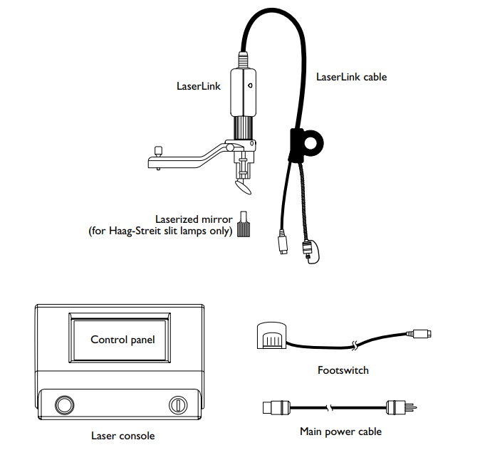
Opal Photoactivator components
Laser console

The laser console houses the main power key switch, emergency off button, treatment and aiming beams, control electronics, power supply and the control panel. The console is the central unit to which all of the other laser components attach.

Control panel

The control panel, located on the front of the laser console, features a touch screen. From the touch screen you can select your treatment settings, view system information, and customize system preferences, such as the footswitch mode.

LaserLink

The LaserLink attaches to your standard diagnostic slit lamp, enabling the slit lamp to be used as a therapeutic device. The LaserLink also houses the spot size control, which allows adjustment of the laser spot size.

LaserLink cable

The LaserLink cable, attached to the LaserLink, is comprised of an electrical cable and an optical fiber cable. The electrical cable provides power for the spot size sensing electronics of the LaserLink. The fiber optic cable transfers the laser light to the slit lamp optics.

Laserized mirror

Lumenis’ laserized mirror replaces your standard Haag-Streit slit lamp illumination mirror. The laserized mirror has a black, non-reflecting coating that eliminates distracting reflections from the backside of the laser delivery mirror.

Footswitch

The footswitch activates the laser treatment beam.

Main power cable

The main power cable connects the laser to the main power source.
Inspecting the components

When unpacking the laser system, and before each use, inspect for dirt, debris, or damage. Check the electrical cables to ensure they are not frayed or split. Ensure that the fiber optic cable is not punctured, fractured, or sharply bent. If cleaning of the components is required, follow the instructions provided in the Maintenance section of this manual. If the any of the components appear damaged, contact your local Lumenis service representative.
Connection Instructions

Connection Diagram for the Opal Photoactivator

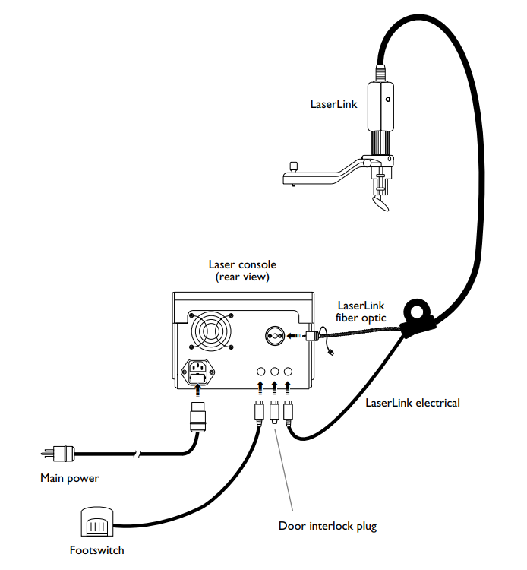

Connections for the Opal Photoactivator
Connection Instructions

Attach the LaserLink to your slit lamp

For Zeiss or equivalent slit lamps

1. If your slit lamp has a tonometer mount, loosen the screw to disengage it. Lift the mount to remove.

2. Align the LaserLink guide pins with their respective slots, and gently lower the LaserLink onto the slit lamp. Ensure that the bottom of the LaserLink is seated flat on the slit lamp. Tighten the screw to secure the connection.

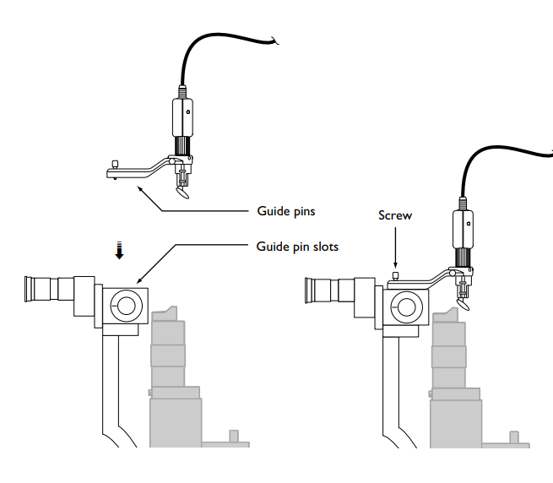
Connect the Zeiss compatible LaserLink
For Haag-Streit or equivalent slit lamps

1. Remove the slit lamp illumination mirror by sliding it out of the illumination mirror holder.

2. Slide the Lumenis laserized illumination mirror, wide end first, into the mirror holder; avoid touching the surface of the mirror.

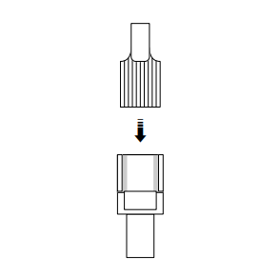
Insert the Lumenis laserized mirror into the mirror holder
3. Carefully lower the LaserLink onto the slit lamp tonometer support post and anchor pin. The LaserLink is properly mounted when the tonometer support post and anchor pin connect firmly into the corresponding receptacles on the LaserLink, as shown.

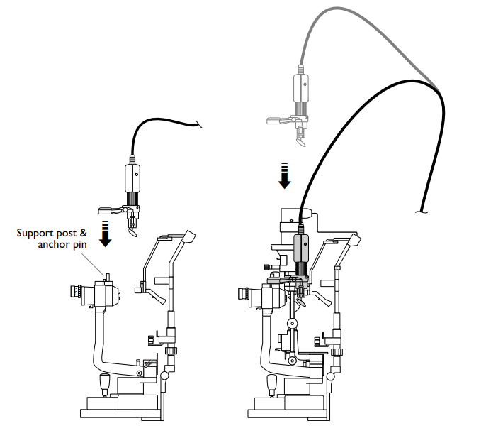

Position and mount the Haag-Streit compatible LaserLink
onto the slit lamp tonometer support post
Connect the LaserLink cable to the laser console

The LaserLink cable is comprised of an electrical cable and an optical fiber cable. The electrical cable provides power for the spot size sensing electronics of the LaserLink. The fiber optic cable transfers the laser light to the slit lamp optics.

1. Plug the LaserLink electrical cable into the LaserLink electrical receptacle, as shown. If the LaserLink electrical cable is not properly connected when the laser is turned on, ✔ displays on the control panel and the laser cannot be enabled.

2. Remove the dust caps from both the fiber optic connector and the fiber optic receptacle, as shown.

3. Insert and carefully secure the LaserLink fiber optic connector into the laser console fiber optic receptacle. If the fiber is not properly connected when the laser is turned on, ✔ displays on the control panel and the laser cannot be enabled.
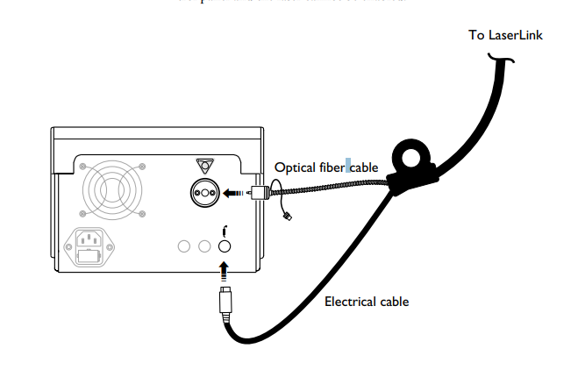
Connect the LaserLink electrical and fiber optic cables to the laser console
Secure the LaserLink cable

Secure the LaserLink cable to the slit lamp headrest using the Velcro® straps.

NOTE
To ensure optimal optical transmission, make sure that the LaserLink cable is not sharply bent.
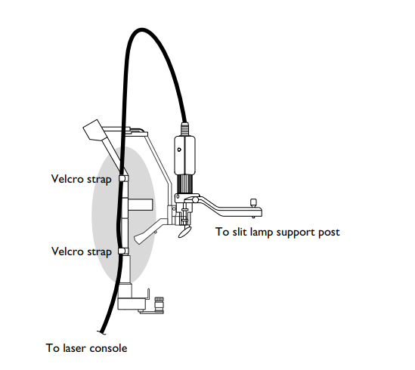
Secure the LaserLink cable to the slit lamp headrest
Connect the footswitch

Plug the footswitch cable into the footswitch receptacle. If the footswitch is not properly connected when the laser is turned on, ✔ displays on the control panel and the laser cannot be enabled.
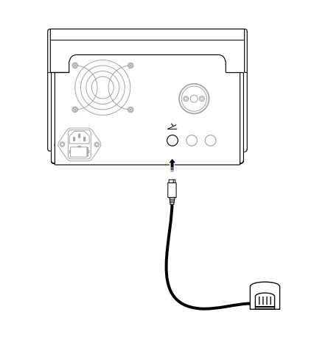
Connect the footswitch
Insert the external door interlock plug

The external door interlock is a safety feature that disables the laser if the treatment room doors are opened or the interlock plug is removed while the laser is in ready mode.

Use of an external door interlock is optional. If you do not use an external door interlock, you must insert the interlock plug into the interlock receptacle on the back of the laser console. The laser remains inoperative until either the external door interlock is set up, as described in the Maintenance section of this manual, or the interlock plug is inserted.

When using an external door interlock, the laser automatically disables and returns to standby mode if the treatment door is opened or the interlock plug is removed. ✔ displays on the control panel. To resume treatment, close the treatment room door or reinsert the interlock plug, and place the laser in ready mode.
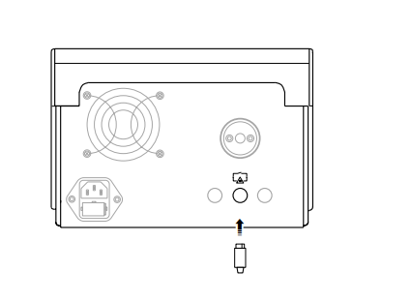

Insert the door interlock plug

Plug in the main power cable

1. Ensure that the laser key switch is turned to the O (off) position.

2. Insert the main power plug into the main power receptacle, as shown.

3. Plug the other end of the main power cable into the electrical outlet.
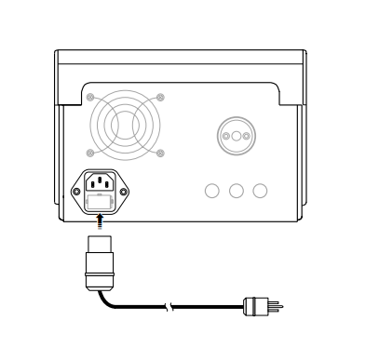
Plug in the main power cable
Laser Basics

Turning on the laser

Ensure that the emergency off button is not pushed in. Insert the key into the key switch and turn to the | (on) position.

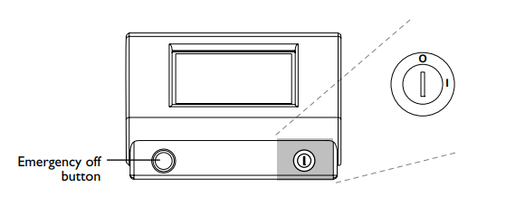
Key switch

A system self-test and warm-up begin. A startup screen showing the progress of the laser self-test and warm-up displays on the control panel.


Startup screen
Laser status – standby / ready

The standby icon indicates that the system is in standby mode. In standby mode, the footswitch is disabled and the treatment beam is not available. The ready icon indicates that the system is in ready mode. In ready mode, the footswitch is enabled and the laser treatment beam is available. The ready mode is only accessible from certain screens. To allow for treatment, the laser goes automatically into ready mode after the infusion timer expires and the Treatment Timer screen displays. The laser can also be placed in ready mode from the Laser Check screen to perform routine laser power checks, and from the Footswitch Mode screen to test the footswitch. The ready icon is also visible on the Aiming Beam Adjustment screen when you access it from the Treatment Timer screen while in ready mode. On all screens where the ready mode is not available, the laser remains in standby mode and no icon is displayed.

WARNING
Except during actual treatment, the laser must always be in standby mode. Maintaining the system in standby mode prevents accidental exposure if the footswitch is inadvertently depressed.

WARNING
Verify that all persons in the treatment room are wearing the appropriate laser safety eyewear before placing the laser in ready mode.

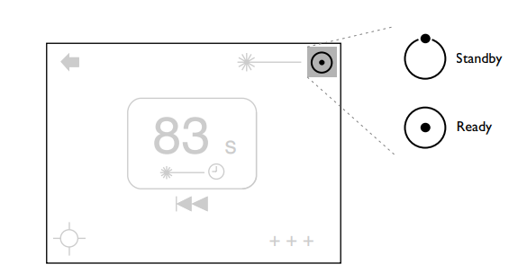
Laser status icons
Laser emission

The laser emission icon indicates that the laser is fully powered and that radiation is accessible.

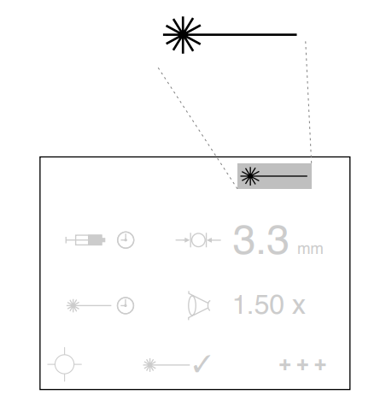
Laser emission icon
Turning off the laser

Under normal operating conditions, turn the key switch to the O (off) position.

Emergency off

In an emergency, press the emergency off button to immediately deenergize the laser.
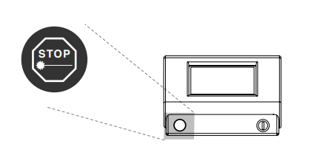
Emergency off button
Disconnecting the laser

1. Turn the key switch to the O (off) position.

2. Unplug the laser power plug from the electrical outlet and the laser console.

3. Unplug the LaserLink electrical cable and remove the fiber optic from the laser console; place the dust cap over the fiber optic end.

4. Remove the LaserLink (and the laserized mirror for Haag-Streit models) from the slit lamp.

5. Store the cables, laserized mirror, and the LaserLink in their carrying cases.
Control Panel Basics

The control panel, located on the front of the laser console, features a touch screen. From the touch screen you can select your treatment settings, view system information, and customize system preferences, such as the footswitch mode.

NOTE
When making control panel selections, use only one finger to press the touch screen. Using more than one finger may result in an inadvertent selection.

Main menu

When the laser has finished warming up, the Main menu displays on the control panel. You can access all of the necessary screens for treatment from the Main menu. From the Main menu, you can also access the screens needed to perform a laser power check and adjust the aiming beam mode and power. Additionally, you can expand the Main menu to access screens for adjusting such items as the screen contrast, volume of the system beeps, treatment protocol parameters, and footswitch mode. Refer to the System Preferences section of this manual for more information.
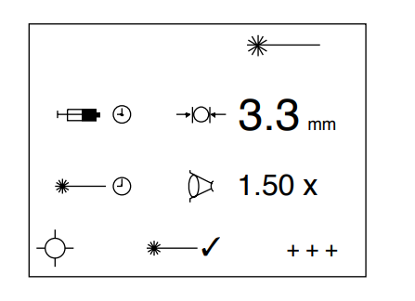
Main menu
Expanding a menu or screen

To expand the Main menu, press the more + + + icon. When available, use + + + on screens to display additional treatment information.

NOTE
If you do not see the + + + icon on a screen, the screen does not expand.
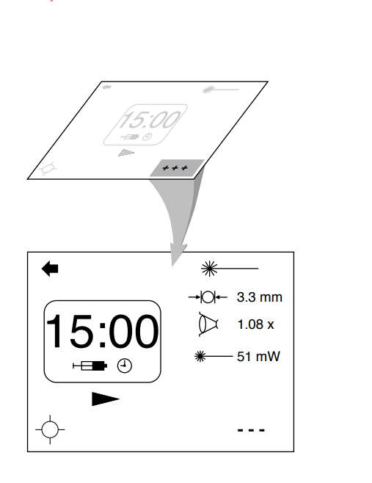
Expand a screen
Returning to a basic menu or screen

To return to a basic menu or screen from an expanded view, press the less - - - icon.

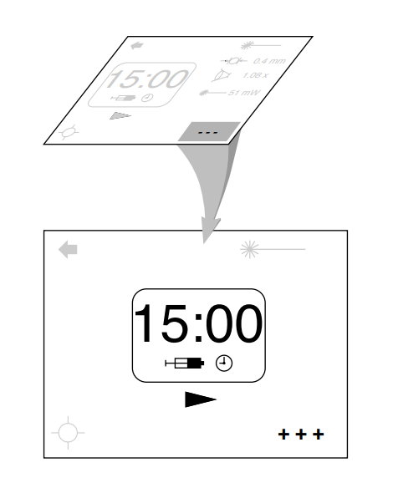
Return to a basic menu or screen
Accessing screens from the Main menu

To access a screen from either the basic or expanded Main menu, press the appropriate icon shown below.

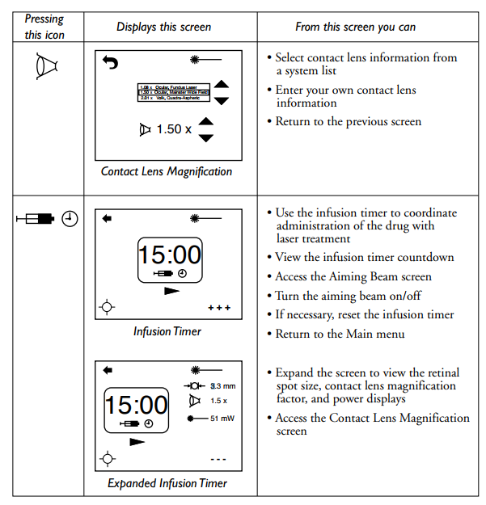
Screen selection icons
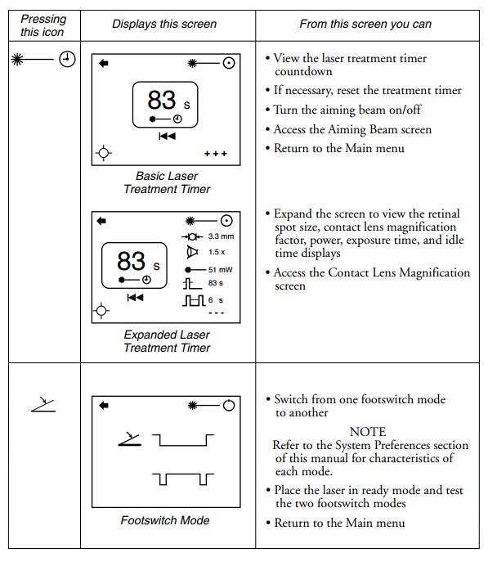
Screen selection icons (continued)
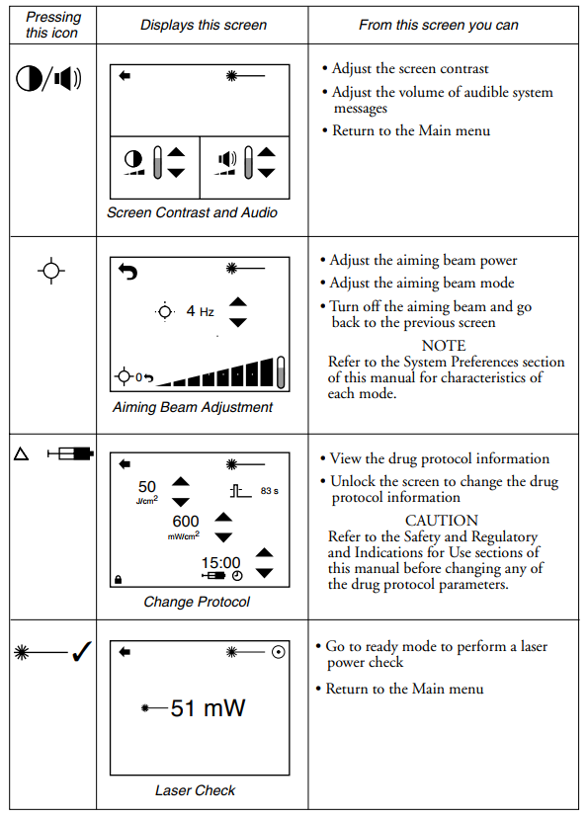
Screen selection icons (continued)
Returning to the Main menu from screens

To return to the Main menu from a screen, press the backicon.

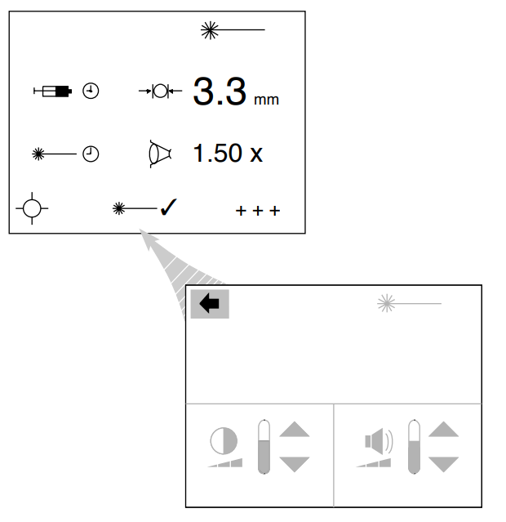
Return to the Main menu from a screen
Accessing a screen from another screen

Certain screens can be accessed from other screens by pressing the screen selection icon. For example, the Aiming Beam Adjustment screen can be accessed from the Infusion Timer screen. Use the return-to-previousscreen icon to return to the originating screen from the accessed screen.

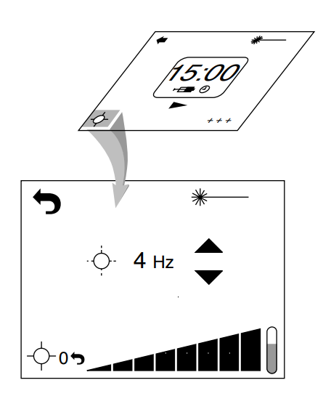
Access a screen from another screen
Pre-treatment Setup

Set up your slit lamp

To ensure there is no focal shift between magnifications and to provide maximum working distance with the contact lens:

1. Ensure the laser is off.

2. Turn on the slit lamp illumination and adjust the brightness intensity.

3. Affix a paper target (e.g., business card) with a piece of tape to the headrest and position the target so it is visible through the slit lamp eyepieces.

4. Set the eyepieces to 0.

5. Set the magnification to the highest setting.

6. Focus the slit lamp on the target by moving the slit lamp with the joystick. Lock the slit lamp base.

7. Set the magnification to the lowest setting. Adjust the eyepieces, alternating from + to - to achieve the best focus on the target. Repeat the procedure for each eye. This step eliminates accommodation.

8. To fine tune the slit lamp focus, repeat steps 5-7.

9. Note the index number of the slit lamp eyepieces relative to the index marks as a future starting point for this procedure.
Set up the LaserLink on your slit lamp

NOTE
Before completing these steps, ensure that a paper target is affixed to the headrest and that it is visible through the slit lamp eyepieces, as described in the previous procedure.

To ensure that the laser beam is focused at the same focal point as the slit lamp binocular:

1. Turn on the laser.

2. Rotate the spot size control on the LaserLink to the minimum spot size available for the current contact lens magnification.

WARNING
Laser focus must only be obtained using the minimum spot size. If a spot size other than the minimum is used, none of the spot sizes will be focused at the same focal point as the slit lamp binoculars

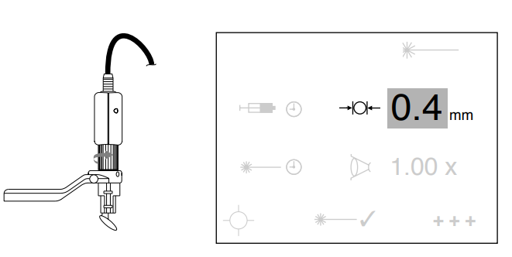Set the retinal spot size to the minimum.
3. From the Main menu, press the aiming beam icon. The Aiming Beam Adjustment screen displays.
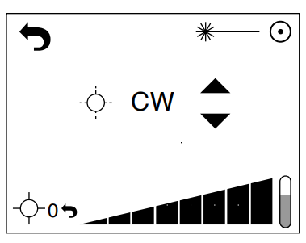
Aiming Beam Adjustment screen

4. Slide your finger to the right over the power control until the red aiming beam is visible on the target.

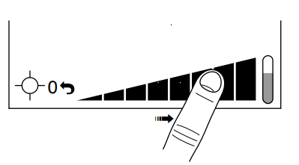
Slide finger over power control

5. Adjust the slit width of the slit lamp to your customary slit width (narrow).
6. Position the aiming beam on the center of the slit by adjusting the horizontal and vertical controls on the LaserLink.

7. Adjust the focus control to obtain the smallest spot size and still maintain an image with crisp edges.

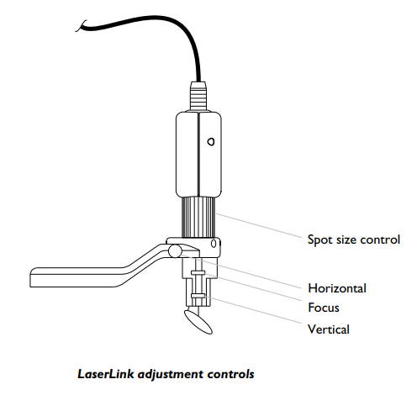
LaserLink adjustment controls

Verify the drug protocol parameters

Verify the drug protocol parameters, as described in the System Preferences section of this manual.

If desired, set up system preferences

To adjust such items as the aiming beam power and mode, footswitch mode, screen contrast, or system message volume, refer to the System Preferences section of this manual.
Selecting Treatment Settings

Select the contact lens magnification factor

After selecting the contact lens you will use on the patient, access the Contact Lens Magnification screen.

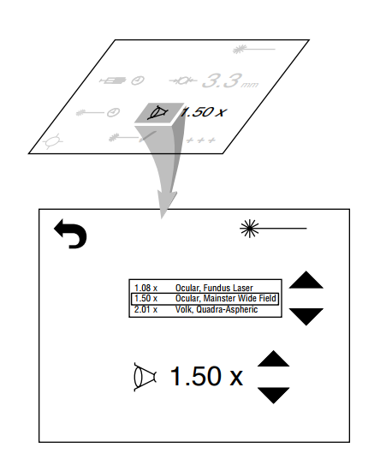
Access the Contact Lens Magnification screen
Select the magnification factor from the contact lens list

Use the up and down arrows to scroll to the desired contact lens. A bold box surrounds your selection. The associated magnification factor also displays. The system beeps to indicate when you are at the top or the bottom of the list.

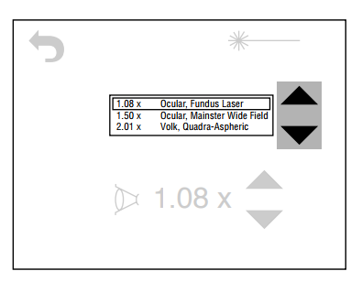
Select a contact lens magnification factor
If the desired selection is not available, enter a contact lens magnification factor

If the desired contact lens is not on the system list, or if you prefer entering it manually, use the up and down scroll arrows to select the desired magnification factor. The lowest contact lens value you may select is 0.40x and the highest is 2.50x. The magnification display indicates the currently selected lens magnification factor.

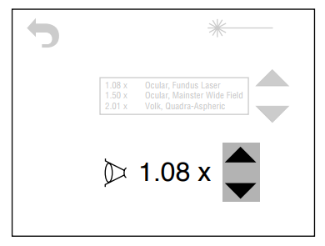
Enter a contact lens magnification factor
Select the spot size on the LaserLink

After selecting the contact lens magnification factor, press the icon to return to the Main menu. Rotate the spot size control on the LaserLink to the desired spot size. The Retinal Spot Size display on the Main menu changes as you rotate the spot size control.

NOTE
The spot size is dependent upon the contact lens magnification factor. Therefore, if you select a different contact lens magnification, the Retinal Spot Size value will change.

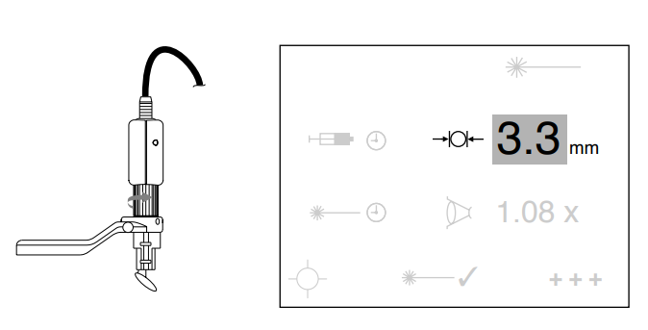
Select the spot size
If desired, complete a laser power check

The laser output power can be measured using a suitable laser power meter, such as the Lumenis LaserCheck power meter included with the laser system. The power meter should be capable of measuring laser power with a range of 5 to 350 mW continuous wave at 689 nm ± 3 nm.

To perform a laser power check:

1. Adjust the retinal spot size to the desired setting.

2. Press the laser check ✓ icon on the Main menu to access the Laser Check screen. The requested output power displays.
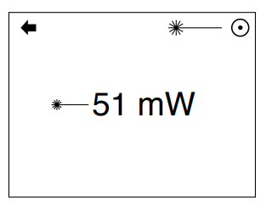
3. Hold the power meter in front of the slit lamp at the focal plane. Center and focus the aiming beam at the middle of the power meter sensor.

4. Place the laser in ready mode.

5. Follow the power meter instructions for sampling the laser power, and press the footswitch to deliver the treatment beam.

6. Check the power meter reading against the power level displayed on the screen
The power meter reading should be within ±20% of the power level displayed on the screen. If it is outside of this limit, do not use the laser. Contact your Lumenis service representative.

WARNING
As a precaution against accidental laser exposure, ensure that anyone checking the power is wearing laser safety eyewear, as described in the Safety and Regulatory section of this manual.
Access the Infusion Timer screen

The infusion timer coordinates administration of the drug with laser treatment. To use the infusion timer, access the Infusion Timer screen. If desired, you can expand the screen to display the retinal spot size, contact lens magnification factor, and power setting. The Contact Lens Magnification screen can also be accessed from the expanded screen.

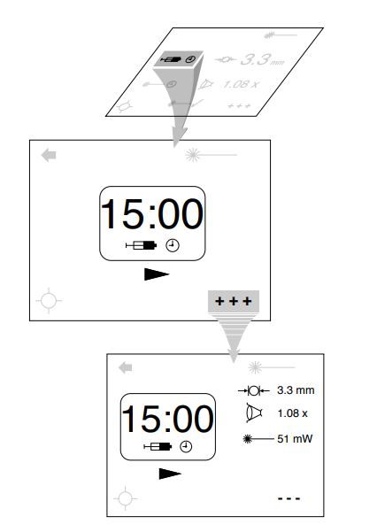
Access the Infusion Timer and Expanded Infusion Timer screens
When the drug is injected, start the infusion timer

When the drug is injected, press the infusion timer start icon to start the infusion timer.

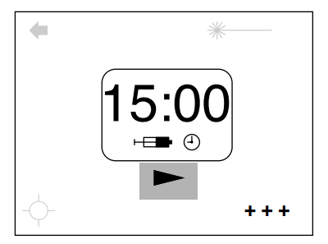
Press the infusion timer start icon

The infusion timer starts the countdown, and the start icon is replaced by the reset icon. The system beeps when the countdown reaches five minutes, one minute, and the final five seconds. At 0, one long beep indicates that the countdown is complete and the system goes into ready mode with the Treatment Timer screen displayed.
If necessary, reset the infusion timer

If you need to reset the infusion timer, first press the reset icon on the Infusion Timer screen to access the Infusion Timer Reset screen. Then, press the reset icon on the Infusion Timer Reset screen to reset the timer and return to the Infusion Timer screen.

NOTE
The infusion timer continues to count down until you press the reset icon on the Infusion Timer Reset screen. If you do not wish to reset the infusion timer, press the start icon to return to the Infusion Timer screen.

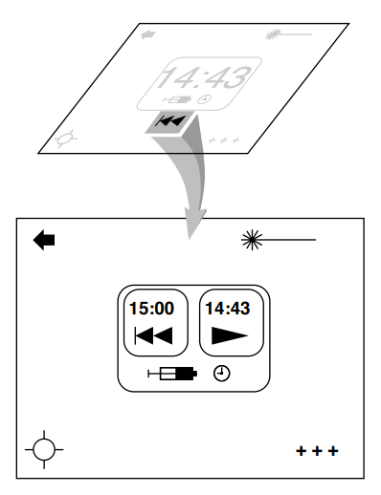
Access the Infusion Timer Reset screen
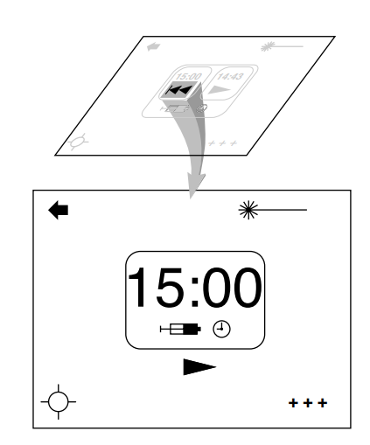
Press the reset icon to reset the timer and return to the Infusion Timer screen
Deliver the treatment beam

After the infusion timer countdown is complete, the system goes into ready mode, and the Treatment Timer screen displays.

NOTE
If you are not using the infusion timer, you can access the treatment timer directly from the Main menu. You must select ready mode to begin treatment.

When you press the footswitch to begin treatment, the treatment timer begins its countdown. If you have selected manual footswitch mode, the treatment and countdown continue as long as you have your foot on the footswitch, or until the timer reaches 0. If you have selected automatic footswitch mode, tapping the footswitch delivers the treatment beam until the timer reaches 0 or until the footswitch is tapped again. If for any reason you stop treatment, the countdown timer stops and the system records the time during which treatment is suspended (“idle time”). When you resume treatment, the treatment countdown continues.

NOTE
If the infusion timer was used, the “idle time” also includes the time between the expiration of the infusion timer and the beginning of treatment.

If desired, you can expand the Treatment Timer screen to display the retinal spot size, contact lens magnification factor, power, exposure time, and “idle time.” The Contact Lens Magnification screen can also be accessed from the expanded screen.
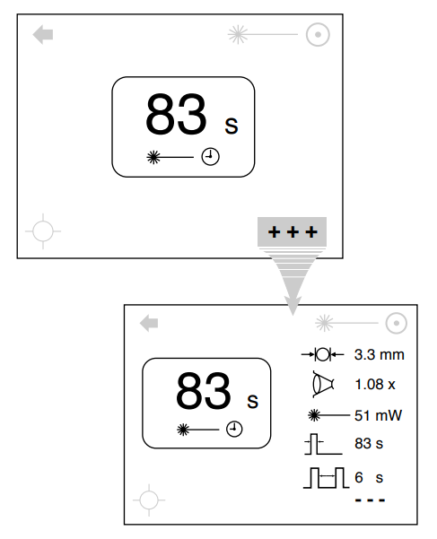
Treatment Timer and Expanded Treatment Timer screens
If necessary, reset the treatment timer

If you need to reset the treatment timer, first press the reseticon on the Treatment Timer screen to access the Treatment Timer Reset screen. Then, press the reset icon on the Treatment Timer Reset screen to reset the timer and return to the Treatment Timer screen.

NOTE
If you do not wish to reset the treatment timer, press the start icon to return to the Treatment Timer screen. You must press the footswitch to resume treatment.

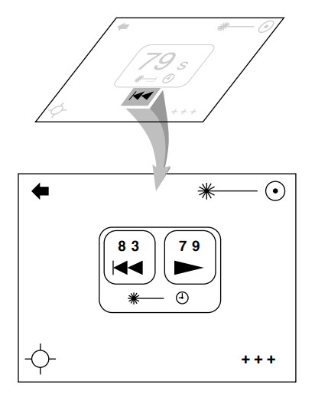
Access the Treatment Timer Reset screen
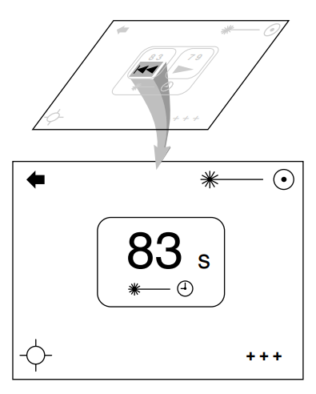
Press the reset icon to reset the timer and return to the Treatment Timer screen
System Preferences

Turning on the aiming beam

If the aiming beam is off, turn it on by pressing the aiming beam icon, located in the bottom left corner of the Main menu, the Infusion Timer screen, and the Treatment Timer screen.

Adjusting the aiming beam

The Aiming Beam Adjustment screen is accessed by pressing the icon. From this screen, you can adjust the aiming beam power and mode.

NOTE
If no selection is made for 7 seconds, the Aiming Beam Adjustment screen no longer displays; the previous screen displays.
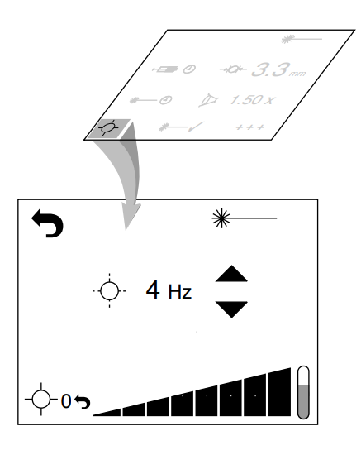
Access the Aiming Beam Adjustment screen
Adjusting the aiming beam power

Slide your finger over the power control to select the desired power.

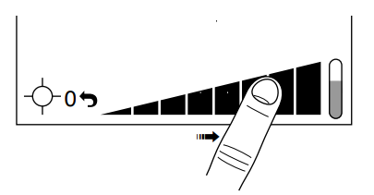
Slide finger over power control

Adjusting the aiming beam mode

Two aiming beam modes are available: continuous and blinking. In continuous mode, the aiming beam does not blink. In blinking mode the aiming beam blinks at the frequency you select.

Selecting continuous mode

To select continuous mode, press the up arrow until CW displays.

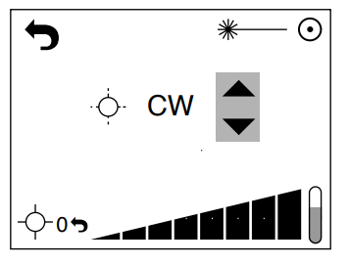
Select continuous mode
Selecting blinking mode

To increase or decrease the rate at which the aiming beam blinks, press the up or down arrow until the desired rate is achieved.

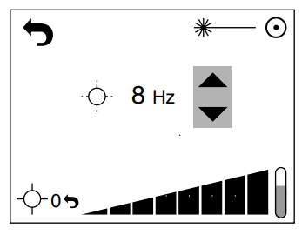
Select blinking mode

Turning off the aiming beam

To turn off the aiming beam, access the Aiming Beam Adjustment screen, then press the 0 icon to turn off the aiming beam and return to the previous menu.
Selecting the footswitch mode

Two footswitch modes are available: manual and automatic. In manual mode, the treatment beam is delivered while you are pressing the footswitch; once you release your foot from the footswitch, the treatment beam is no longer delivered. In automatic mode, you press the footswitch once and then take your foot off of the footswitch; the treatment beam is delivered until you either press the footswitch again or until the laser automatically turns off when the treatment timer runs out.

To select a footswitch mode, access the Footswitch Mode screen from the Expanded Main menu.
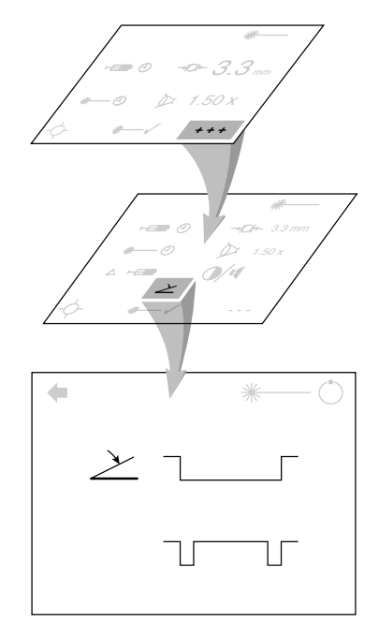
Access the Footswitch Mode screen
Press the desired mode button. The footswitch icon displays next to the active mode.

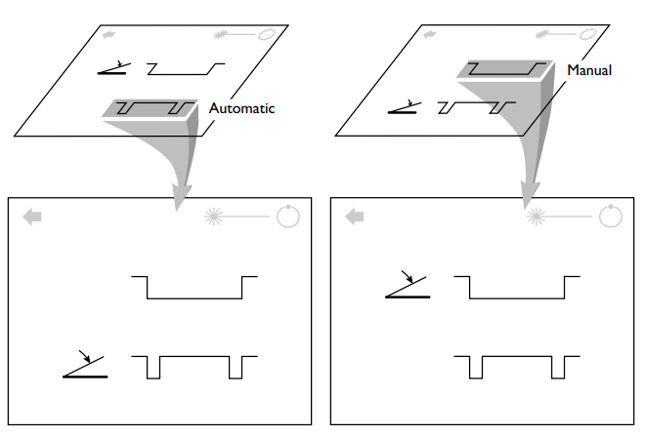

Select the desired footswitch mode
Adjusting the screen contrast and the volume of audible system messages

Access the Contrast and Audio screen from the Expanded Main menu. Use the corresponding up and down arrows to adjust the screen contrast and volume of system messages.

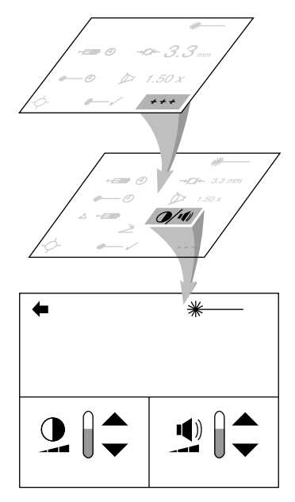
Access the Contrast and Audio screen
Viewing the drug protocol parameters

Access the Change Protocol screen from the Expanded Main menu.

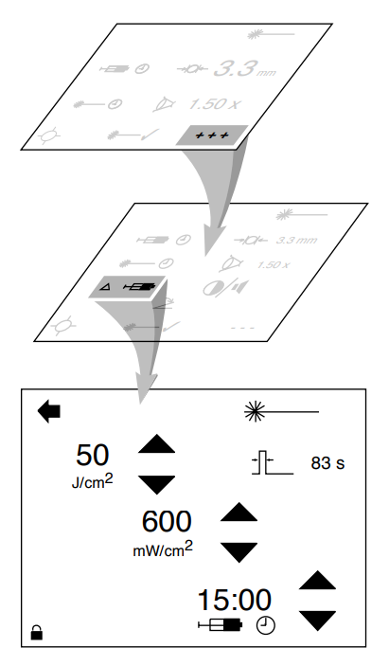
Access the Change Protocol screen
Changing the drug protocol parameters

CAUTION
Refer to the Safety and Regulatory and Indications for Use sections of this manual before changing any of the drug protocol parameters.

To change the drug protocol parameters:

1. Press the icon to unlock the screen.

2. Press the up and down arrows to adjust the fluence, intensity, and infusion time. The exposure time will be calculated automatically.

3. Press the back icon to return to the Main menu. The new drug protocol parameters will be saved and the Change Protocol screen locked.

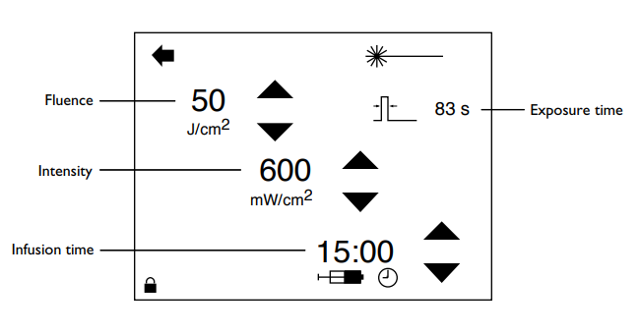
Change Protocol screen
Preoperative Instructions

1. Ensure that the laser is properly connected, as described in the Connection Instructions section of this manual.

2. Post the “Laser in Use” warning sign outside the treatment room door.

3. Ensure that all persons in the treatment room are wearing the appropriate laser safety eyewear. See the Laser Safety Eyewear section of this manual for detailed information.

4. Ensure that your slit lamp and LaserLink are set up, as described in the Pre-treatment Setup section of this manual.

5. Verify the drug protocol parameters, as described in the System Preferences section of this manual.

6. If desired, adjust the other laser controls such as the aiming beam mode and footswitch mode, as described in the System Preferences section of this manual.
Intraoperative Instructions

1. Position the patient.

2. Choose the patient’s contact lens and select the magnification factor, as described in the Selecting Treatment Settings section of this manual.

3. Select the spot size on the LaserLink.

4. When the drug is administered, start the infusion timer.

5. When the infusion timer expires and the treatment timer displays, press the footswitch to deliver the treatment beam to the tissue.
Postoperative Instructions

When patient treatment is complete and the laser goes into standby mode:

1. Turn off the laser.

2. If applicable, remove the “Laser in Use” sign from the treatment room door.

3. If desired, disconnect the laser as described in the Laser Basics section of this manual.

4. Clean the laser console and LaserLink, as instructed in the Maintenance section of this manual.
Maintenance

Troubleshooting Guide

If the instrument fails to operate properly, this troubleshooting guide will help you to locate and correct the malfunction. First, please check for the following items:

1. Electrical power source…verify that the electrical disconnect switch, the circuit breaker, is turned on.

2. Laser console electrical…verify that the laser is on and properly connected to an electrical service outlet.

3. Delivery system connections…verify that the delivery system is properly connected.

4. External door interlock...if the external door interlock is used in conjunction with a remote switch, verify that the external door interlock plug is inserted in the external door interlock receptacle. Close the interlocked door.
Laser does not turn on, and the control panel does not illuminate

Probable Cause: The laser is not plugged in.
Suggestion: Place the electrical service disconnect switch in the off position, plug the laser power cord into the appropriate outlet, and turn the electrical service disconnect switch to the on position.

Probable Cause: The building power (main electrical service) is turned off.
Suggestion: Turn on the building power.

Probable Cause: The emergency off button is pushed in.
Suggestion: Press the emergency off button to release.

Inadequate aiming beam or no aiming beam

Probable Cause: The aiming beam is set to the lowest power.
Suggestion: Refer to the Operation section of this manual, then adjust the aiming beam power.

Probable Cause: The laser or LaserLink components are not properly connected.
Suggestion: Refer to the Operation section of this manual, then check the connections.

Probable Cause: The fiber optic connector is damaged.
Suggestion: Contact your local Lumenis service representative.

No treatment beam is delivered when the footswitch is depressed, or the beam is of poor quality

Probable Cause: The laser or LaserLink components are not properly connected.
Suggestion: Refer to the Operation section of this manual, then check the connections.

Probable Cause: The LaserLink is misaligned.
Suggestion: Contact your local Lumenis service representative.

Probable Cause: The fiber optic connector is damaged.
Suggestion: Contact your local Lumenis service representative.
Probable Cause: The laser optics are dirty or out of alignment.
Suggestion: Contact your local Lumenis service representative.

Inadequate laser power

Probable Cause: The laser optics are dirty or out of alignment.
Suggestion: Contact your local Lumenis service representative.

Inadequate slit lamp illumination

Probable Cause: The illuminator intensity is not in the proper position, or the illuminator bulb is burned out.
Suggestion: Refer to your slit lamp operator manual.

Probable Cause: Slit adjustments are needed.
Suggestion: Refer to your slit lamp operator manual.
System faults and advisory messages

System hard faults, such as “F16,” are displayed on an otherwise blank screen. To clear a system fault, turn the laser off then on again. If the fault persists, contact your local Lumenis service representative.

Advisory messages, which are displayed in the top center of the screen, are user-correctable as described below.

✔ advisory message displays on the control panel

Probable Cause: The remote interlock has been activated.
Suggestion: Make sure that whatever activated the remote interlock has been corrected. For example, if opening the operating room door activated the interlock, close the door. If no action has occurred, refer to the Operation section of this manual, then check the remote interlock connection.

✔ advisory message displays on the control panel

Probable Cause: The LaserLink fiber optic is not properly connected.
Suggestion: Refer to the Operation section of this manual, then check the LaserLink fiber optic connection.

✔ advisory message displays on the control panel

Probable Cause: The footswitch is not properly connected.
Suggestion: Refer to the Operation section of this manual, then check the footswitch cable connection.

✔ advisory message displays on the control panel

Probable Cause: The LaserLink electrical cable is not properly connected.
Suggestion: Refer to the Operation section of this manual, then check the LaserLink electrical cable connection.
advisory message displays on the control panel

Probable Cause: The spot size has changed during treatment.
Suggestion: Refer to the Operation section of this manual, then set the spot size back to value set at the beginning of treatment.

<5 mW advisory message displays on the control panel

Probable Cause: The requested power is too low.
Suggestion: Refer to the Operation section of this manual, then adjust the contact lens magnification factor and/or LaserLink spot size.

>300 mW advisory message displays on the control panel

Probable Cause: The requested power is too high.
Suggestion: Refer to the Operation section of this manual, then adjust the contact lens magnification factor and/or LaserLink spot size.
Inspect and Clean the Opal Photoactivator

Before and after each use, inspect the laser and LaserLink components for dirt, debris, or damage.

WARNING
Always disconnect the LaserLink from the laser before inspection.

NOTE
Do not touch any optical lens; finger oils may damage the delicate coatings.

Cleaning the laser console external surface

To clean the external surface of the laser console, wipe using a cloth dampened with a noncaustic cleaning solution. Dry with a clean cloth, or allow to air dry. Do not spray or pour cleaning agents directly on the laser console.

Cleaning the LaserLink

Periodically inspect the eye safety filter and beam delivery mirror. If necessary, clean the surfaces as follows:

1. Turn off the power to the slit lamp and laser.

2. Wrap a piece of lens tissue (Kodak® or equivalent) around one end of a cotton-tipped applicator (Puritan® or equivalent non-glue tip applicator).

3. Place several drops of reagent or 100% ethanol or methanol on the tissue.

4. Wipe the optic gently in one direction with lens tissue to remove all dust and debris. Do not wipe in more than one direction, as loose particles might be dragged across the surface and scratch the optical coating.

NOTE
The LaserLink optics have delicate coatings. When cleaning, wipe them gently and avoid getting fingerprints on them. If an optic appears to be damaged, contact your local Lumenis representative.
Cleaning the fiber optic connector

To clean the fiber optic connector, use a cotton-tipped swab moistened with high-grade acetone or alcohol.
External Door Interlock Pin Assignments

The external door interlock is a safety feature that disables the laser if the treatment room doors are opened or the interlock plug is removed while the laser is in ready mode.

The interlock can be set up with a remote switch, or an external switch can be wired to the interlock plug. Plug wiring shall only be performed by a qualified electrical professional. Total length of cable shall not exceed five meters (16 feet).

Pin assignments are as follows:

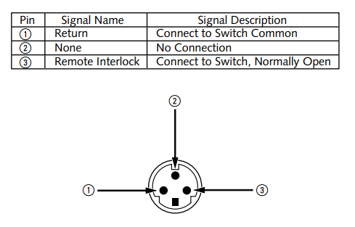
External door interlock pin assignments (mating face shown)
Changing the Fuses

1. Turn off the laser.

2. Remove the power plug from the electrical outlet.

3. Remove the other end of the power cable from the main power receptacle. Next to the main power receptacle is the fuse cartridge receptacle, as shown.

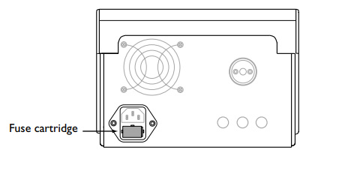
Location of fuse cartridge receptacle

4. Using a small flathead screwdriver, gently push against the two locking tabs on either side of the fuse cartridge until the cartridge pops up from its receptacle.
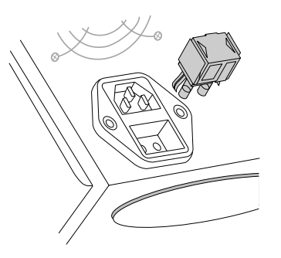
Pop up the fuse cartridge

5. Remove the cartridge and replace the fuses as marked.

6. Gently push the fuse cartridge back into the receptacle until the locking tabs latch.
Calibration Procedure

Regulatory agencies require that manufacturers of US FDA CDRH Class III and IV and European EN 60825 Class 3 and 4 medical lasers supply their customers with power calibration instructions.

DISCLAIMER WARNING
Calibration is a service procedure to be done only by Lumenis-certified service engineers or customers who have taken and passed a Lumenis Service Certification Training course. Adjustment by anyone other than a trained Lumenis service engineer or a certified customer voids any existing manufacturer’s warranty on the instrument. A service manual for the laser may be purchased from Lumenis. It is company policy not to distribute service tools outside of the Lumenis service organization. Possession of service instructions or tools does not authorize repair or modification of a Lumenis instrument by uncertified personnel.

We recommend that your laser be calibrated annually. Calibration must be performed by an engineer or technician qualified to work on energized electronic laser equipment. Calibration questions should be referred to your local Lumenis representative.

Power calibration

1. Ensure that all personnel are wearing the appropriate laser safety eyewear.

2. Remove the bottom cover of the laser console, and place the console on its side.

3. Turn on the laser.

4. Turn on the aiming beam at an arbitrary power level in CW mode.

5. Place a power meter detector head at the slit lamp focal plane, and position the detector head so that the aiming beam emitted from the LaserLink strikes the power meter properly.

6. Turn off the aiming beam.

7. Set SW1 on the main PCB to the service position.
8. From the Master Service screen, select the “Laser Diode” button. The Laser Diode Test screen should appear.

9. Press the “Light” then “On” buttons to turn on the treatment laser and put the unit into light control mode.

10. Adjust the laser power to 200 mW using the “Power Set DAC” controls, and monitor the “Main Photocell” indicator.

11. Adjust pot R68 until the power meter reads 200 mW.

12. Verify that the “Main Photocell” indicator reads 200 mW +/- 10 mW.

13. Adjust pot R52 until the “Safety Photocell” indicator reads 200 mW +/- 10 mW.

14. Adjust the laser power using the “Power Set DAC” control to 300 and 50 mW requested levels. Verify that both the “Main Photocell” and “Safety Photocell” indicators are within +/- 10% of values measured by the power meter at each of the requested levels.

Spot size calibration

1. Ensure that all personnel are wearing the appropriate laser safety eyewear.

2. Remove the bottom cover of the laser console, and place the console on its side.

3. Turn on the laser.

4. Set SW1 on the main PCB to the service position.

5. From the Master Service screen, select the “Spot Size” button. The Spot Size Calibration screen should appear.

6. Rotate the spot size control on the LaserLink counterclockwise until the spot size voltages are at a minimum, then press the “Save Min” button.

7. Rotate the spot size control on the LaserLink clockwise until the spot size voltages are at a maximum, then press the “Save Max” button.
Specifications

Specifications subject to change without notice.

Treatment laser

Type
Aluminum Gallium Indium Phosphorus (AlGaInP) diode

Principal output
90% of treatment power within ±3 nm of 689 nm

Operating mode
Continuous wave

Power
5 - 300 milliwatts delivered to slit lamp focal plane

Power/time control
Determined by intensity, fluence, spot size, and contact lens magnification inputs

LaserLink spot size
400-5000 micrometers diameter at slit lamp focal plane

Retinal spot size
Dependent on the product of the contact lens magnification and the LaserLink spot size and limited by available output power

CDRH classification
Class IIIb

EN 60825 classification
Class 3B
Aiming laser

Type
Diode

Principal output
635 nanometers wavelength

Power
Variable from barely visible to < 1 milliwatt

CDRH classification
Class II

EN 60825 classification
Class 2

Console physical characteristics

Height: 13 centimeters (5 inches)
Width: 18 centimeters (7 inches)
Depth: 30 centimeters (12 inches)
Weight: 3.2 kilograms (7 pounds)

Input power, single-phase

100-230 V~ (AC), 50/60 Hz, 110 W

Cooling

Air-cooled

Environmental requirements

Operational (calibrations valid)

Temperature range: 15° to 35° C
Maximum humidity: 90% relative humidity non-condensing

Non-operational

Temperature range: -20° to 85° C
Maximum humidity: 90% relative humidity at 55° C non-condensing
Electrical standards

Designed to meet UL2601-1, IEC 601-1, IEC 601-2-22, IEC 801-1/2/3/ 4/5, IEC 825-1, and CSA22.2

Footswitch

Not intended for use in operating rooms

Compatible slit lamps

Zeiss SL 130, Zeiss 30 SL, and Haag-Streit 900BM

Laser safety eyewear

Refer to the Laser Safety Eyewear section of this manual for laser safety eyewear information.

Compatible contact lenses

Volk, Area Centralis 1.04x
Haag-Streit 901 Fundus Lens 1.04x
Ocular, Mainster Standard 1.05x
Ocular, 3 Mirror Universal Long (direct) 1.08x
Ocular, 3 Mirror Universal Short (direct) 1.08x
Ocular, Fundus Laser 1.08x
Volk, Trans Equator 1.44x
Ocular, Mainster Wide Field 1.50x
Ocular, Mainster Ultra Field PRP 1.9x
Volk, SuperQuad 160 1.92x
Volk, Quadra-Aspheric 2.01x
Warranty Information

For specific and detailed warranty information for this instrument, please refer to the first page of your purchase “Agreement” and the last page of the “Terms and Conditions of Sale.”

Decontamination of Returned Equipment

To comply with United States postal and transportation law, equipment shipped to Lumenis US offices for repair or return must be properly decontaminated with a chemical germicide that is commercially available and cleared for use as a “Hospital Disinfectant.” To ensure that all equipment has been properly decontaminated, a signed Decontamination Certificate (provided at the back of this manual) must be enclosed in the package, or Lumenis will assume that the product is contaminated and will assess the customer with cleaning costs.

Any decontamination inquiries should be directed to the Lumenis US service offices.
Safety and Regulatory

The Opal Photoactivator is classified as a Class IIIb laser by the Center for Devices and Radiological Health of the Food and Drug Administration and as Class 3B by the International Standard IEC 60825.

Users must take precautions to prevent exposure of laser energy to the eyes and skin from either direct or diffusely reflected laser beams, except as a therapeutic application. Additional precautions must be taken to prevent fire, electrical injury, and explosion.

Lumenis does not make recommendations regarding the practice of medicine. Laser treatment parameters are provided as a guide. Individual treatment should be based on clinical training, clinical observation of lasertissue interaction, and appropriate clinical endpoints.

See the American National Standard (ANSI) publications Z136.3-2005, ANSI Z136.1-2000, and EN 207 for recommendations on the safe use of lasers in health care facilities.
Laser Safety Eyewear

Laser safety eyewear is routinely required with most lasers. When using the laser system, the Laser Safety Officer should determine the need for safety eyewear based on the Maximum Permissible Exposure (MPE), Nominal Hazard Zone (NHZ), the Nominal Ocular Hazard Distance (NOHD), and the optical density (OD) for each of the available laser emissions and the configuration of the treatment room (usually within the controlled area). For additional information, refer to ANSI Z136.1-2000, ANSI Z136.3-2005, International Standard IEC 60825-1: 2001, Appendix A, or European Standard EN 60825-1:2001, Appendix A.

The following formula was used to calculate the worst case NOHD for Lumenis Opal Photoactivator lasers and compatible delivery systems:

NOHD = Z 

where,

Z = the distance of the beam waist from the laser system;
a = the beam waist diameter (1/e2 of axial irradiance for gaussian beam);
θ = minimum full angle beam divergence (1/e2 of axial irradiance for gaussian beam);
e ≈ 2.7182818285, the base of natural logarithms;
Φ = maximum energy of one laser pulse or maximum CW laser power;
Pf = the profile correction factor (1 for uniform profile or 2 for gaussian irradiance profile;
MPE = Maximum Permissible Exposure, in energy density units (energy per unit area), or power density units (power per unit area);
NOHD = the Nominal Ocular Hazard Distance (measured from laser aperture); = the distance required to reduce the energy density or power density to the MPE.
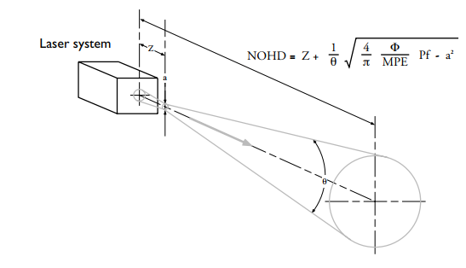
Using this approach we derive the following values:

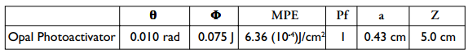

which results in a worst case NOHD of :

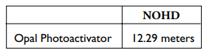

All personnel who are within the NOHD are considered to be within the controlled area and shall wear eye protection with a minimum optical density (OD) of:

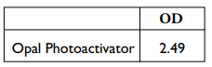
Laser safety eyewear must also be resistant to physical damage or photobleaching resulting from laser exposure as per ANSI Z136.1-2000, section 4.6.2 and Appendix C. For users who must comply with EN 207, the safety eyewear must have a protection class of L3 or greater.

In addition to providing the required laser safety eyewear, take the following steps to secure the treatment room, or the controlled area:

1. To alert personnel before they enter the controlled area, place a warning sign on the outside of the treatment room door when the laser is in use.

2. Close the treatment room door during operation of the laser.

3. External door interlocks that automatically disable the laser when the treatment room door is opened may be installed.

NOTE
A blocking barrier, screen, or curtain capable of blocking or filtering the laser beam could be placed to create a controlled area inside a large treatment room. The barrier should be made of material that can withstand the power of the treatment beam for the maximum exposure time, relative to the configuration of the controlled area and the treatment parameters for the specific medical application.
Additional Ocular Protection

WARNING
Always verify that the delivery device is properly connected to the laser. An improper connection may result in an inadvertent secondary laser beam. Severe eye or tissue damage could occur.

WARNING
Never substitute prescription eyewear for the appropriate laser safety eyewear, as severe eye damage could occur. Prescription eyewear can concentrate the laser light to the eye and/or can be shattered by a high power density beam, possibly causing severe eye damage.

WARNING
Severe and irreversible eye damage and scarring may occur from direct or indirect exposure to the treatment beam. The predominant ocular structures at risk are dependent on the laser wavelength in use. In general, visible and nearinfrared wavelengths are most damaging to the retina, while ultraviolet or infrared wavelengths are most damaging to the cornea and sclera. Severity of injury depends on how concentrated or diffused the treatment beam is and the length of exposure. A thorough understanding of the specific ocular risks and safety precautions for each laser wavelength is necessary to ensure the safety of the patient and operating personnel.

WARNING
Never look directly into any optical lens, except for therapeutic purposes, nor any optical fiber, probe, or laser system aperture while the laser is energized. Severe eye damage could occur. Turn off the laser before inspecting any delivery system or laser components.
Additional Safety Considerations

WARNING
Do not use this device in the presence of flammables or explosives, such as volatile anesthetics, alcohol, certain surgical preparation solutions, and similar substances. An explosion and/or fire could occur.

CAUTION
US federal law restricts this device to sale by or on the order of a physician.

CAUTION
Lumenis medical lasers and laser delivery systems are intended solely for physicians trained in the use of these instruments.

CAUTION
Use of controls or adjustments or performance of procedures other than those specified herein may result in hazardous laser radiation exposure.

NOTE
This package conforms to the conditions and limitations specified in US federal regulations, title 49 CFR 173.426 for radioactive material, excepted package-articles manufactured from natural thorium, UN 2910.

Electrical Hazards

WARNING
Never open the laser console protective covers. Opening the covers will expose personnel to line voltages at the input to the low voltage power supply and other AC wiring, as well as to possible laser radiation. Only Lumeniscertified service technicians shall work inside the console.

WARNING
The area around the laser and footswitch should be kept dry. Do not operate the laser if any of the cords are faulty or frayed. The laser should undergo routine inspection and maintenance per Lumenis manufacturer’s recommendations and institutional standards.
Protecting nontarget tissues

WARNING
Unintended tissue damage can occur due to incorrect energy, repetition rate, exposure duration, or power application. The lowest energy, repetition rate, exposure duration, or power settings that are effective for the intended application should be used until familiar with the instrument’s capabilities. Extreme caution should be employed until you understand the biological interaction between the laser energy and tissue.

WARNING
Except during actual treatment, the system must always be in the standby mode. Maintaining the system in the standby mode prevents accidental laser exposure if the footswitch is inadvertently depressed.

CAUTION
To prevent accidental laser discharge, always turn off the laser before connecting a delivery system.

CAUTION
Never place hands or other objects in the path of the laser beam. Severe burns could occur.

CAUTION
Only the person directing the aim of the laser beam should have access to the laser footswitch. Use caution depressing the laser footswitch when it is in proximity to footswitches for other equipment. Make sure the footswitch depressed is the correct one to avoid accidental laser exposure.
Regulatory Compliance

Lumenis lasers and delivery systems comply with 21 CFR Chapter I, Subchapter J, as administered by the Center for Devices and Radiological Health of the US Food and Drug Administration (FDA).

CE-labeled devices comply with all appropriate performance standards as specified in Annex II of the European Medical Device Directive MDD 93/42/EEC.

Emergency off push-button

The laser has an emergency off push-button which immediately turns off the laser.

Key lock switch

To prevent unauthorized use, the laser can only be turned on with the master key, the key can only be removed when the laser is turned off, and the laser only operates when the key is inserted into the keyswitch. When the keyswitch is turned to the on position, the laser power-up sequence is initiated.

Location of controls

Operation and adjustment controls are located so that the user need not be exposed to laser radiation during laser operation or adjustment.

Protective housing

The laser has a protective housing that prevents unintended human access to laser radiation above Class I limits. The housing must only be opened by a Lumenis-certified technician.

Remote interlock

An external door interlock receptacle and plug are provided to disable the laser if the treatment room doors are opened while the laser is in ready mode. Refer to the Laser Safety Eyewear section of this manual for additional information.
Safety interlocks

The protective housing is not designed to be removed by the user during operation or maintenance. Therefore, the laser does not have, and is not required to have, any safety interlocks within the meaning of US FDA 21 CFR, Section 1040 or European EN 60825-1. However, the protective housing cannot be easily opened without special tools. Additionally, the laser has a safety interlock on the fiber optic connector. If the fiber is removed during system operation, ✔ displays on the control panel and the system will not deliver a treatment beam. The treatment laser can be set in the ready mode only if the fiber is properly connected.

Manual reset

If laser emission is externally interrupted during treatment by remote interlock activation, the laser will automatically go into standby and the safety shutter will revert to a closed position. To resume treatment, manually reset the laser by placing the laser in ready mode. If laser emission is interrupted during treatment by main electrical power loss, the laser system will automatically turn off. To resume treatment after an electrical power loss, the system must be manually restarted by rotating the keyswitch to the on position.

Electronic fault detection circuitry

If the electronic system detects a fault condition, laser exposure cannot occur. The safety shutter closes and the treatment laser and footswitch are disabled.

Some fault conditions may be cleared by the operator. Refer to the Troubleshooting Guide in this manual for additional information.

Safety shutter

The laser includes an electronic safety shutter that prevents unintentional laser emission. The safety shutter closes when the system is turned off, during self-test at system turn on, and when the safety monitor detects a fault.
Laser emission indicator

The laser emission indicator displays on the control panel at laser startup to alert the user that laser radiation will be accessible after the laser self-test and warm-up. The time delay is incorporated to allow appropriate action by the user to avoid unintentional laser exposure. The indicator continues to display on the control panel as long as the laser is powered on to provide a visible warning to the user that laser radiation is accessible.
Location of regulatory and other system labels

As required by national and international regulatory agencies, appropriate warning labels have been mounted in specified locations.

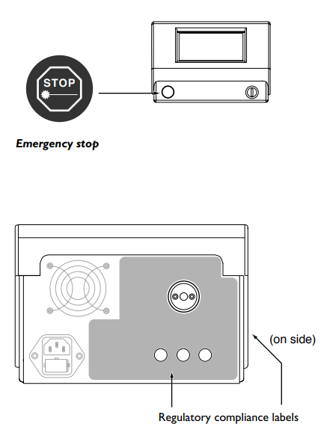

Location of regulatory compliance labels


Regulatory compliance labels
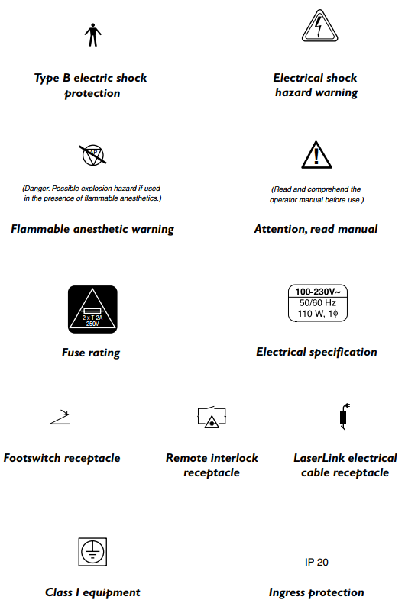

Regulatory compliance labels
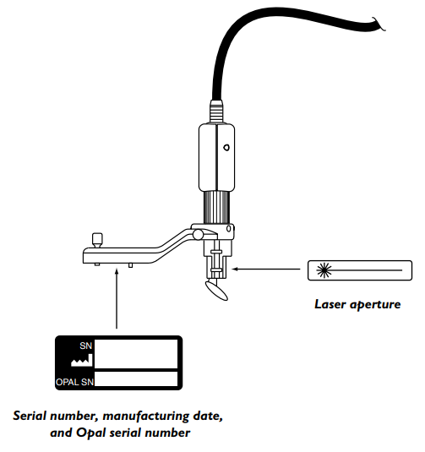

Location of regulatory compliance labels for the Zeiss compatible LaserLink
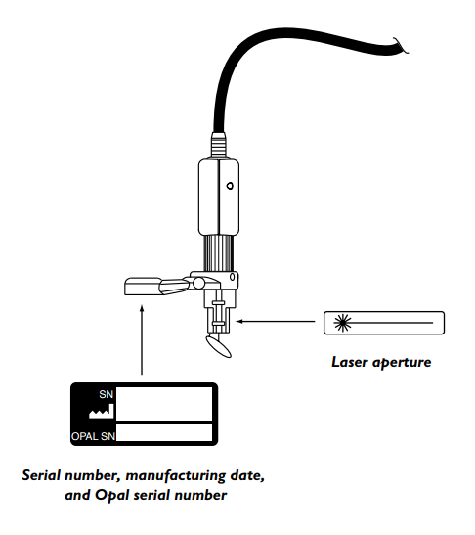

Location of regulatory compliance labels for the Haag-Streit compatible LaserLink

Indications for Use

The Lumenis Opal Photoactivator laser console and modified Lumenis LaserLink adapter are intended for use in photodynamic therapy as sources of photoactivation of VISUDYNE™ (verteporfin for injection) for the treatment of age-related macular degeneration (AMD) in patients with predominantly classic subfoveal choroidal neovascularization (CNV).

Refer to the VISUDYNE Package Insert for information and instructions for use of the drug and for information on laser power, duration, and light dose.

Potential Adverse Effects of the Device on Health

Adverse effects of the Lumenis Opal Photoactivator could be related to inappropriate dosages or improper use of the device. Such events should not occur if the conditions and instructions for use are followed, as fully described in the Package Insert for VISUDYNE (verteporfin for injection).

Decontamination Certificate

Under the provisions of Postal Law, Title 18, United States Code, Section 1716, and Department of Transportation regulations contained in CFR 49, Part 173.386 and 173.387, “etiologic agents, diagnostic specimens and biological products…are nonmailable…”

The undersigned therefore certifies that the Lumenis equipment being returned herein by
_________________________________ __________________________________
I ndividual/Institution City, State

has undergone decontamination with a commercially available germicide cleared for use as a “Hospital Disinfectant” and is clean and free from biohazards, including - but not limited to - human or animal blood, tissue or tissue fluids or components thereof.

The undersigned also agrees to reimburse Lumenis for any costs incurred in cleaning the enclosed equipment, in the event said item(s) is/are received by Lumenis in a contaminated condition.

_________________________________ __________________________________
Model Model

_________________________________ __________________________________
Serial Number Serial Number

_________________________________ __________________________________
Lumenis RMR Number Lumenis RMR Number

_________________________________ __________________________________
Typed/Printed Name Position/Title

_________________________________ __________________________________
Signature Date

